PROJECT REPORT

**Introduction:**

We all have Laptops, Smart phones where we have Calendar Application which gives daily update about date and day. In this project we are going to implement it with a simple look and feel. It is a Console based Application which means input and output is taken from command prompt, and it is developed using C Programming language. This application does not have any graphics or GUI, but it is simple to understand and use. A User can interact with this application using command prompt.

Calendar displays simple information like displaying dates, days and months of a year based on the input entered by user. We will be using Ubuntu C Terminal which is Linux Environment on Windows for development of this application.

**Features:**

Below are the features will be implemented as part of this Project.

1. Displays Calendar of entire year including Dates, Days and Months where year is taken as input from user through command prompt. Ex: When 2020 is given as input from user this application would display entire Calendar of 2020 year.
2. It also has a feature when a user gives input of Date, Month and Year then corresponding Day is given as output. Ex: When a user gives input like 26 Dec 2020 then it would display Saturday as output.

**Algorithm :**

1. Start
2. Take user input between these 3 choices.
3. Find out the day
4. Print the year calendar
5. Exit
6. Read user choice
7. If choice is 1, store it in variable called choice.
8. If choice is 2, store the value in choice and if choice is 3, store the value in choice.
9. Choice 1: (i) Read date, month, year (dd-mm-yyyy) from user

(ii) If it is leap year then weekday = (date+=month<3?year--:year- 2,23*month/9+date+4+year/4-year/100+year/400)%7 **; (see references 1)**

(iii)If the entered day is Monday, Sunday, Tuesday, etc. it prints by following switch case.

1. Choice 2: (i) Read year (yyyy) from the user

(ii) months are declared as type char

(iii) month_day is declared as type int

(iv) By using if statement we get whether February has 28 or 29 days (leap year)

(v) By using 2 for loops we print the dates and days in an order

(vi) Declare a function get_the_1st_weekday to know whether the year is leap year or not

day = (((year-1)*365) + ((year-1)/4) -((year-1)/100) + ((year)/400)+1) % 7;

1. Choice 3: Exit the execution.
2. Stop

**OUTPUT:**

1. This is the main page

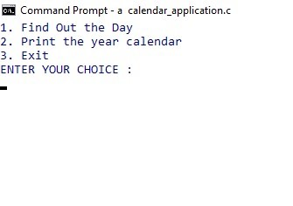

1. This screenshot is related to choice 1

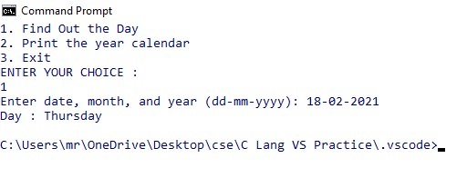

1. These screenshots are related to choice 2

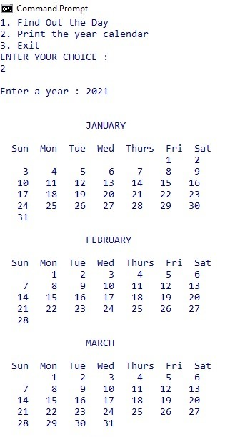 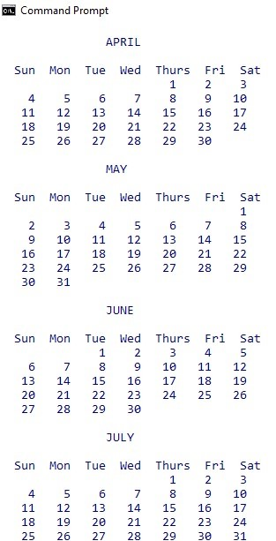

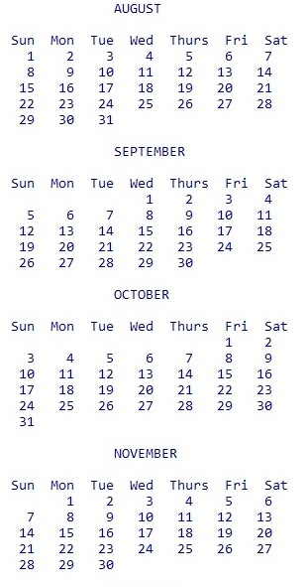 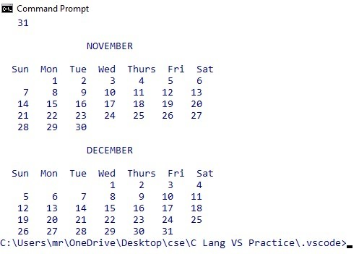

1. This screenshot is related when choice 3 is entered

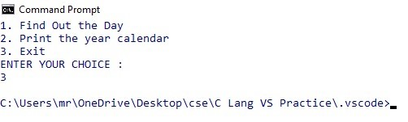

**Conclusion:** This program helps to know the day by entering dd-mm-yyyy and helps to get the year calendar whenever it is useful. It is also an easy task.

**References:**

1. <https://en.wikipedia.org/wiki/Determination_of_the_day_of_the_week>

This link is used for Gregorian date into numerical day of week.